Team 11

Members: Yuheng Lin(yuhelin), Hongrui Chen(hc44)

Game name: Shoot and Die

Main idea: This game is a PVP 2D shooting game, two users use nunchuk controller to move left and right and shoot. The game ends when one of the players run out of health. The game will be like the game shown below.

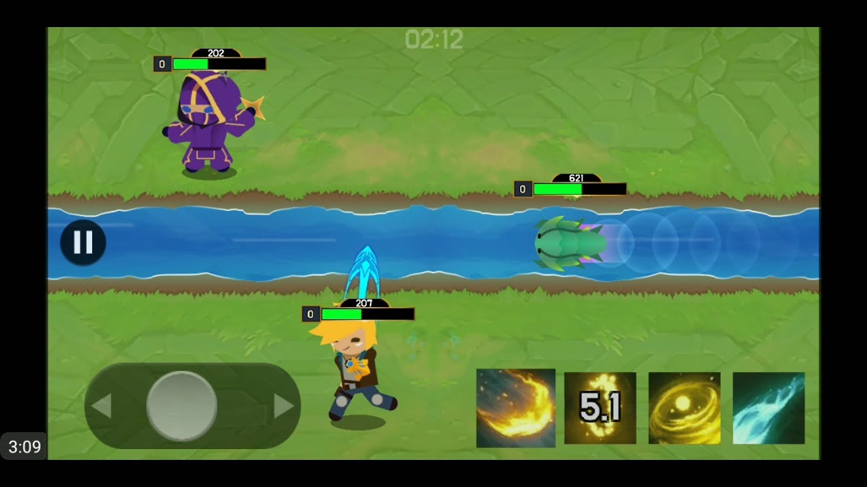Intend to use the required peripherals:

* LCD(Yuheng, Hongrui)

- Display the gameplay

* Audio(Yuheng)

- The background music of the game

* User Input(Hongrui)

- To declare the name of player 1 and 2

* Nunchuk(Yuheng)

- Control the movement and shooting of the players

* Nunchuk Accelerometer(Hongrui)

- Define the direction that players shoot

* SD card(Yuheng)

- Store our audio

* LED(Hong rui)

- use the leds to represent the health of the players